**Programing Assignment 3**

**Vivek Singh # 50208473**

**Report the results for the five query images and the results snapshot. Include a general discussion about the search engine performance and how it can be improved. Also comment about  
the quality of the code and the way it is organized and any take away from doing this hands on  
assignment**

**Resuls:**

**1)** Pass % = 5/5=100%

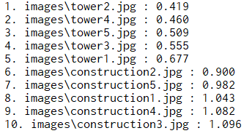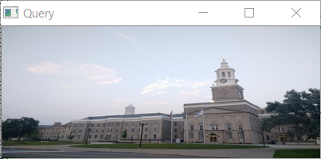

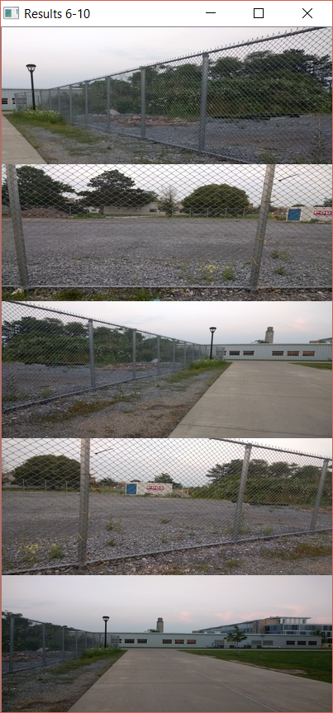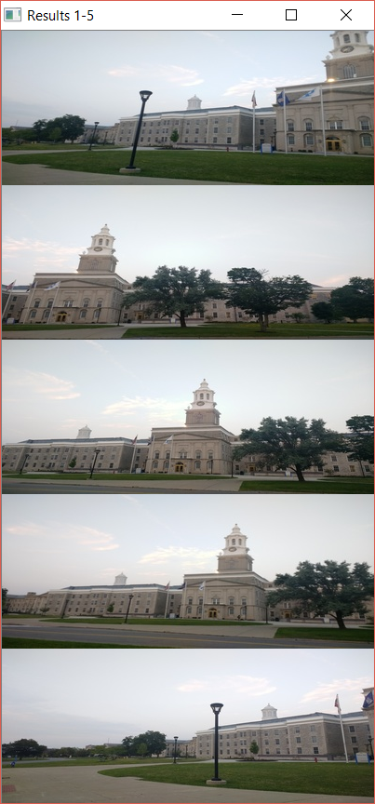

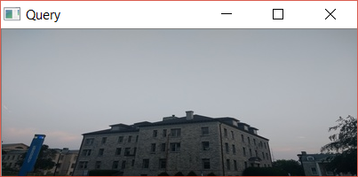**2)** Pass % = 2/5 = 40%

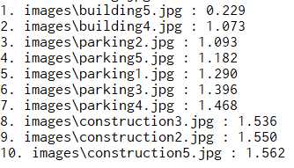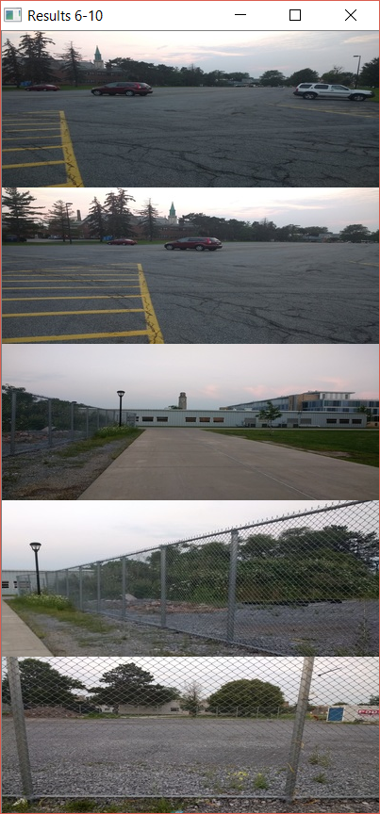

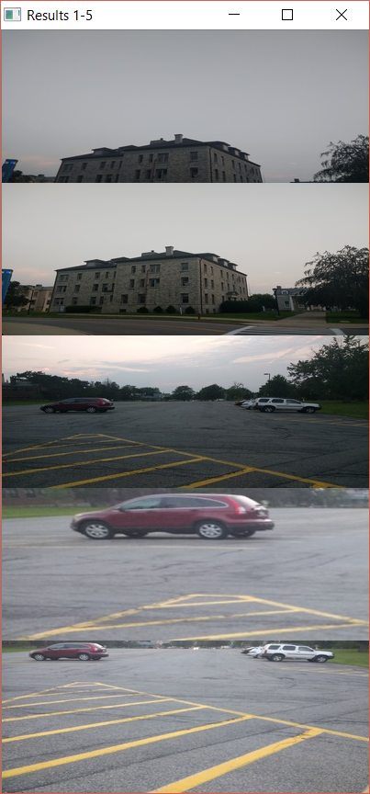

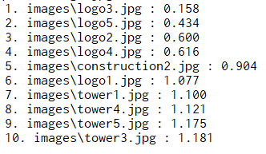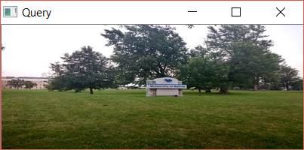3) Pass % = 4/5= 80%

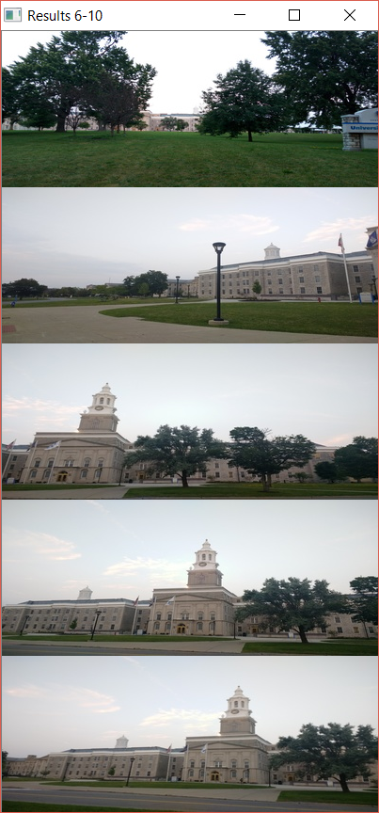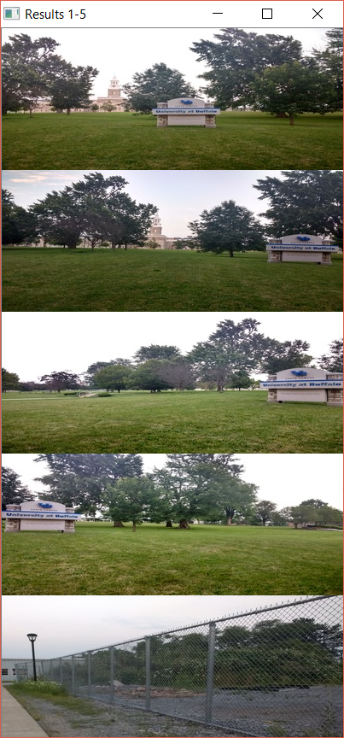

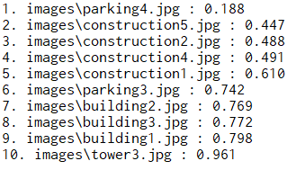**4)** Pass % = 1/5 = 20%

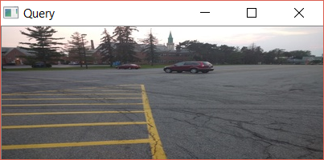

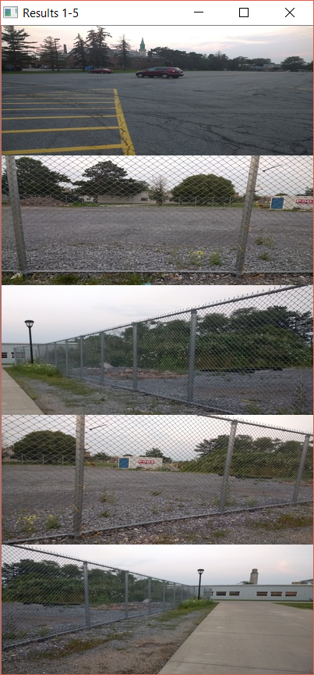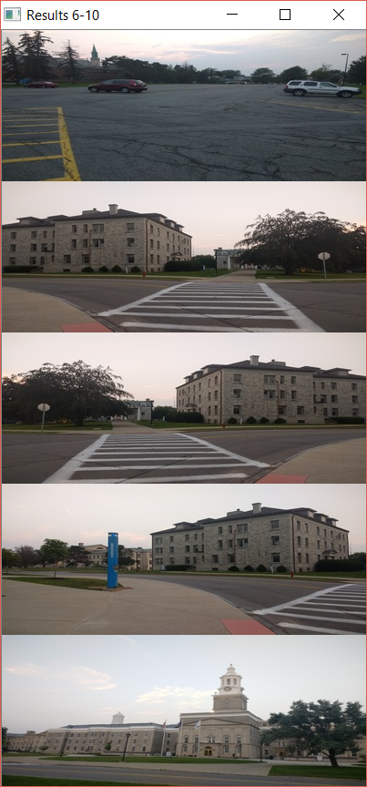

**5)**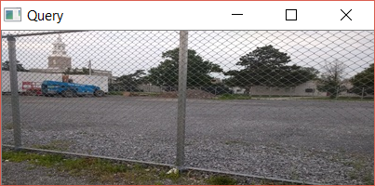 Pass % = 4/5=80%

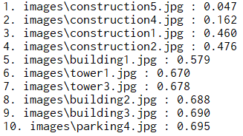

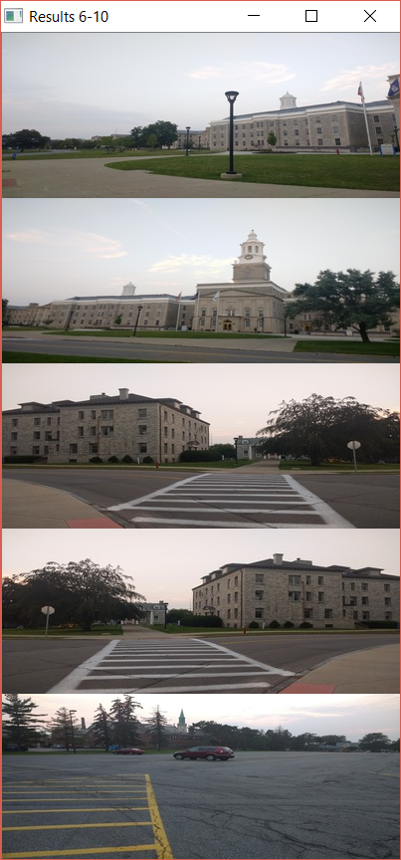

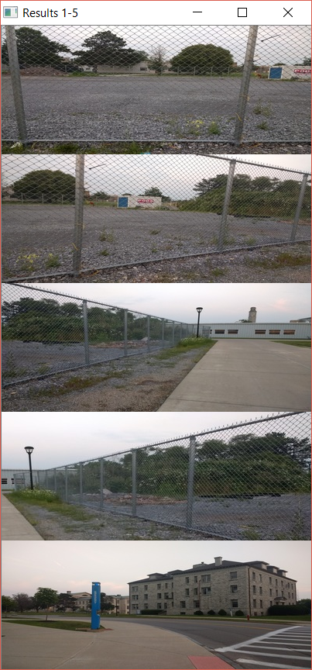

**Performance:**

The overall performance of the search engine based on the top 5 result is 64%.

**General discussion about the search engine performance and how it can be improved**

Since the image data set and query ser contained multiple images of different locations with similar color distribution, the search results failed in those instance. For the image with varying color distribution, the search engine performed fairly well.

As observed, the biggest problem was the mixing up of search results of different locations with similar color distribution.

This occurs because the feature space used to compute score is purely RGB histogram. To increase the accuracy, we could use variety of image descriptors to define the feature space, some of hem being SIFT features or SURF features while indexing and comparison.

Also, performance can be improved by chosing appropriate similarity function in accordance to the descriptors used.

**Comment about the quality of the code and the way it is organized and any take away from doing this hands on assignment.**

The quality of code was standard and presented in a way that is easy to understand and debug.

The biggest take away is to learn how a problem statement is converted to working code that is modular, flexible and easy to understand. It gives the understanding on how to implement the concepts, keeping in mind the flexibility and modularity of the code.